
Copper City Softball Little League
All Star Policies and Procedures

1.1 Players Intent to Participate
• League Director formulates list of all eligible players. All players are automatically nominated unless prohibited by LL rules.
• Player Agents will review forms with database to ensure all eligible players are listed.
• To be completed by end of May.

1.2 Player Selection Process:
a. Softball 10/12 Player Selection by vote:
• Eligibility:
- 11/12 Softball. All players who meet the Little League requirements for 11/12 Majors, are placed on the All-Star ballot.
- 9/10 Softball. All players who meet the Little League requirements for 9/10 Minors, are placed on the All-Star ballot.
- Players are eligible for the All-Star ballot in the division in which they play during the regular season.
• Voting:
- All 11/12 softball, and 9/10 Softball Managers vote for up to 15 players for their respective leagues.
- The voting process will be administered and overseen by President, VP, Player Agent and/or Division Director.

• The top 12 in total votes automatically make the team.
• If there is a tie for the 12th spot, the Manager gets to choose the player or elect to take up to 13 players.
• If a player chooses not to play, then the next player based on vote count between 11-15 will be asked to play
• Once players are selected, a parent or guardian will be given “Post-Season Tournament Parental Consent Form” (the “Commitment Form”).

b. Other All-Star Teams -- Player Selection by Manager:
• If CCSLL so chooses, a 2nd all-star team can be formed and player selection will be by Manager.

1.3 Manager Selection Process:
• Any manager or rostered coach in good standing from each league is eligible to be manager of an All-Star team for their respective age league level.
• Exception is only Major Division Managers are eligible to manage the Little League (11-12’s) All-Star team.
• Interested individuals must submit their names to League Director.
• League Director presents names to managers in the division, at a meeting of managers from the division. Each candidate will be allowed 2 minutes to speak. After all candidates speak, the managers will vote by show of hands for each candidate. If a manager is unable to attend, a proxy vote will be allowed. Proxy vote will be read to all by League Director. No one will be allowed to abstain from voting, and a manager must vote for himself/herself if on ballot.
• The candidate with the most votes will be named manager.
• If there are more than 2 candidates and there is a tie for the most votes, the ones not tied are eliminated. A re-vote will take place for only those that are tied.
• If there are only 2 candidates and the vote ends in a tie, then the League Director, President, and VP will each cast a ballot on paper. Those ballots will be read out loud to all present without divulging who voted for whom. If any of those 3 are managers in that league, then player agent will vote.
• All selected managers must have CCSLL board approval.

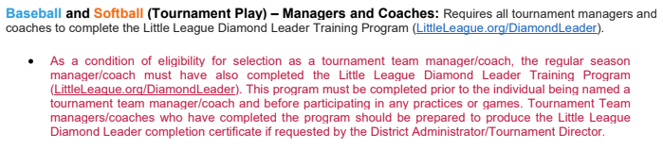
1.4 Coach(es) Selection Process:
• All Star assistant coaches are selected by the Manager.

